Assignment No.6
Name: - Bhavin Ratansing Patil
Roll No.: - 26 SEDA

Que 1. Perform the following queries on given tables.

Book Table Publisher Table Book Author Table
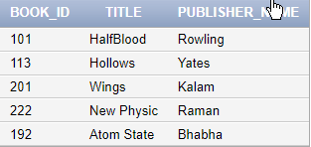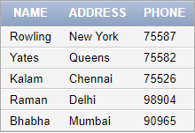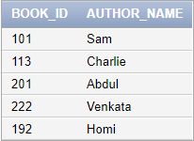

Book Copies Book Loans Table
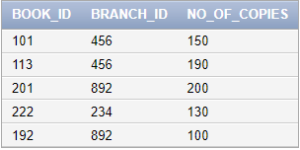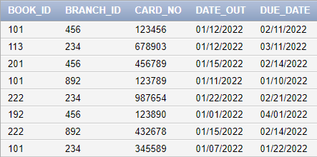

Library Branch Table Borrower Table
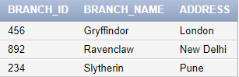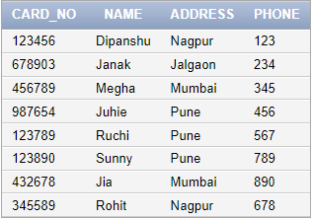

- Get the total number of books written by author Abdul.
SELECT COUNT(BOOK_ID) FROM BOOK_AUTHOR WHERE AUTHOR_NAME='Abdul';
COUNT(BOOK_ID)
1

- List book names which are not yet issued by anyone till date.
SELECT TITLE FROM BOOK WHERE BOOK_ID NOT IN (SELECT BOOK_ID FROM BOOK_COPIES)

no data found

- How many times the book with id 113 is issued ?
SELECT COUNT(BOOK_ID) FROM BOOK_COPIES WHERE BOOK_ID=113;
COUNT(BOOK_ID)
1

- List author names who have written less number of books.
SELECT AUTHOR_NAME FROM BOOK_AUTHOR WHERE BOOK_ID IN( SELECT BOOK_ID FROM BOOK_COPIES WHERE NO_OF_COPIES =(SELECT MIN(NO_OF_COPIES) FROM BOOK_COPIES));
AUTHOR_NAME
Homi

- Get the average number of books in library branch id 456.
SELECT AVG(COUNT(BRANCH_ID)) FROM LIBRARY_BRANCH WHERE BRANCH_ID = '456' GROUP BY BRANCH_ID;
AVG(COUNT(BRANCH_ID))
1

- List the publisher names with less than 2 book publications.
SELECT NAME FROM PUBLISHER WHERE NAME IN(SELECT PUBLISHER_NAME FROM BOOK GROUP BY PUBLISHER_NAME HAVING COUNT(PUBLISHER_NAME)<=2);
NAME
Bhabha
Kalam
Raman
Yates
Rowling

- Get borrower details who have issued ‘ABC’ book in the month of Jan 2022 from 15th Jan to 31st Jan.
SELECT * FROM BORROWER WHERE CARD_NO IN(SELECT CARD_NO FROM BOOK_LOANS WHERE DATE_OUT BETWEEN '1/15/2022' AND '1/31/2022');
CARD_NO | NAME | ADDRESS | PHONE
456789 | Megha | Mumbai | 345
987654 | Juhie | Pune | 456
432678 | Jia | Mumbai | 890

- Which library branch (name ) has 200 copies of book ‘Wings’
SELECT BRANCH_NAME FROM LIBRARY_BRANCH WHERE BRANCH_ID=(SELECT BRANCH_ID FROM BOOK_COPIES WHERE BOOK_ID=(SELECT BOOK_ID FROM BOOK WHERE TITLE='Wings') AND NO_OF_COPIES=200);
BRANCH_NAME
Ravenclaw

- Retrieve the names of all borrowers who do not have any books checked out.
SELECT NAME FROM BORROWER WHERE CARD_NO NOT IN(SELECT CARD_NO FROM BOOK_LOANS);
no data found

- How many books are written by each author ?
SELECT COUNT(DISTINCT BOOK_ID),AUTHOR_NAME FROM BOOK_AUTHOR GROUP BY AUTHOR_NAME;
COUNT(DISTINCTBOOK_ID) | AUTHOR_NAME
1 | Homi
1 | Sam
1 | Abdul
1 | Charlie
1 | Venkata

- Get the book titles issued by Janak from Slytherin branch library.
SELECT TITLE FROM BOOK WHERE BOOK_ID =(SELECT BOOK_ID FROM BOOK_LOANS WHERE CARD_NO=(SELECT CARD_NO FROM BORROWER WHERE NAME='Janak') AND BRANCH_ID=(SELECT BRANCH_ID FROM LIBRARY_BRANCH WHERE BRANCH_NAME='Slytherin'));
TITLE
Hollows

- For each book that is loaned out from the Slytherin branch and whose DueDate is today, retrieve the book title, the borrower's name and the borrower's address.
SELECT B.TITLE, BW.NAME, BW.ADDRESS FROM ((BOOK B INNER JOIN BOOK_LOANS BL ON B.BOOK_ID = BL.BOOK_ID)INNER JOIN BORROWER BW ON BW.CARD_NO = BL.CARD_NO) WHERE BL.BRANCH_ID=(SELECT BRANCH_ID FROM LIBRARY_BRANCH WHERE BRANCH_NAME='Slytherin') AND BL.DUE_DATE=SYSDATE;
no data found

- Get the month name along with the total number of books loaned out in that month.
SELECT TO_CHAR( DATE_OUT,'MON'),COUNT(TO_CHAR( DATE_OUT,'MON')) FROM BOOK_LOANS GROUP BY DATE_OUT;
TO_CHAR(DATE_OUT,'MON') | COUNT(TO_CHAR(DATE_OUT,'MON'))
JAN | 2
JAN | 1
JAN | 2
JAN | 1
JAN | 1
JAN | 1

- Get the list of co-authors with the author ‘PQR’ for book ‘TEST’
SELECT COAUTHOR FROM BOOK_AUTHOR WHERE AUTHOR_NAME = 'PQR' AND BOOK_ID =(SELECT BOOK_ID FROM BOOK WHERE TITLE ='TEST');

- List all publisher names with or without the book title .
SELECT PUBLISHER.NAME, BOOK.BOOK.TITLE FROM PUBLISHER LEFT JOIN BOOK ON PUBLISHER.NAME = BOOK.PUBLISHER_NAME

NAME | TITLE
Rowling | HalfBlood
Yates | Hollows
Kalam | Wings
Raman | New Physic
Bhabha | Atom State

